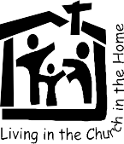
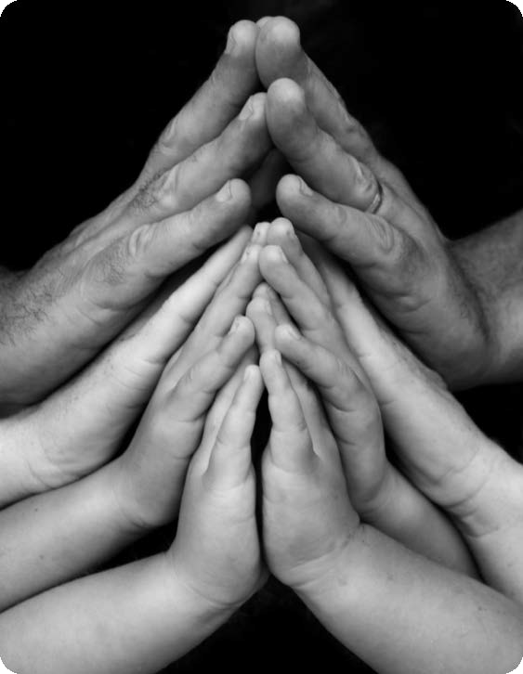
MARFAM
Marriage and Family Life Renewal Ministry
cel 0825521275 email : info@marfam.org.za
www.marfam.org.za
CONTENTS:
*
- BEATITUDES FOR GRANDPARENTS
- A GRANDPARENTS’ MOVEMENT PRAYER AND BLESSING
Grandparents’ prayer Grandchildrens’ prayer BLESSING OF GRANDPARENTS
- A MOVEMENT OF PRAYER FOR GRANDPARENTS FOR GRANDCHILDREN

- STORIES AND ARTICLES
The Fears and Gifts of the Elderly from FAMILY MATTERS 2015
Who do you Say I am from Jubilee 2000 booklet with drawing. available in English, Afrikaans, Zulu and Sotho
Relating - a Scripture reflection activity from PARENTING A LABOUR OF LOVE
Article: Grandparents by Zama Ndlovu
Article : FATHER - GRANDFATHER - WHICH TO CHOOSE. Peter Stohr
- POEMS and SNIPPETS :
GRANDPARENTS MATTER
CARING FOR PARISH FAMILIES
A MARFAM RESOURCE from our archives

BEATITUDES FOR GRANDPARENTS
Blessed are the poor in spirit …. as they will not see their grandparents as a mealticket to the future.
Blessed are the gentle, as they will recognise and be patient with the weaknesses of old age.
Blessed are they who mourn, and who comfort the bereaved and lonely in their loss. Blessed are they who hunger and thirst for justice, …. that the old and weak will not be cast aside but be treated with dignity and respect.
Blessed are they who are merciful and who forgive the old for the faults and failings of yesteryear.
Blessed are the pure in heart, who see the old and young as they really are.
Blessed are the peace-makers and the agents for reconciliation between generations. Blessed are they who accept with grace the wisdom of old age.
Blessed are they who can look back on a life of integrity and know they are loved. Blessed are they who do not judge their young, so that they will not be judged.
Blessed are those who are persecuted because they do what is right, standing up with courage to defend what they have learned through the years.
Blessed are the old and the young, children, parents and grandparents who acknowledge with gratitude the great gift of life they have been given to share.
……… for the Kingdom of God is theirs.
TRowland MARFAM 26 July 2001
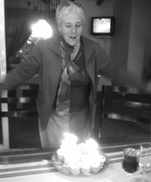
THE GRACE AND MISSION OF GRANDPARENTS - Pope Francis
Pope Francis said, ”Old age has a grace and a mission, and one testimony that can come to young people from this period of life is "fidelity." Society may discard the elderly, but God never discards anyone and calls us to follow him in all stages of life.The elderly may have more free time which can be devoted more to a spirituality for this stage. “Thank God there is the witness of the aged saints!"
“Grandfathers and grandmothers form the permanent 'choir' of a great spiritual sanctuary, where their prayer of supplication and praise supports the community that works and battles on in the field of life."
"How ugly is the cynicism of an old man who has lost the sense of his witness, despises the young and does not communicate his life's wisdom! How beautiful on the contrary the encouragement an old man can convey to the young man in search of the meaning of faith and life! This really is the mission of grandparents. Their words contain something special for the young. And they know it. I still carry with me the words my grandmother gave me in writing on the day of my priestly ordination. I read them often, and they do me good. I would welcome a church that challenges the culture of waste with the overflowing joy of a new embrace between the young and the old! T.”
Pope Leo’s theme for 2026 is “I will not forget you.” In 2025 his focus was on hope, a constant source of joy, whatever our age. “Blessed are they who have not lost hope. The elderly are signs of hope while we all can be signs of hope for them. They are signs of a living love and have their roots in God himself. They give us courage and remind us that “even if our outer self is wasting away, our inner self is being renewed day by day by our encounter with him in prayer and in Holy Mass. Let us lovingly pass on the faith and hope we have lived for so many years, in our families and in our daily encounter with others.
A GRANDPARENT'S LOT
No doubt there's much that's changing in the families today. We gather not for Sunday lunch where cousins meet and play.
At grandp's house we'd meet and share for each to have their say On joys and struggles facing us along the family way. The grandp's of today may live alone or have some kids to stay It could be that they have no kids at all or kids are far away. Or Just maybe it's our lot to grandparent another way.
I've seven grandkids but that's not all, it could change any day There could be more than just one cat, four dogs, 12 love- birds, who's to say! Love from Granny Toni
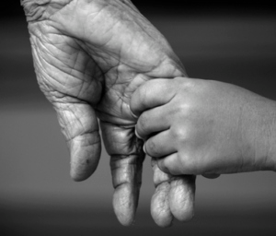
We know how grandparents love their grandchildren and are proud of them, but many are seriously concerned about them, young and older. They are often close but also often find it difficult to understand one another.
Older people may have more time and a greater desire for a deeper prayer life. They also feel helpless and no longer useful in life. This movement can help grandparents to recognise the important contribution they can still make in the lives of their families no matter how far away.
There is no formal structure or procedure for this movement, but it is nice to be able to share with others and form a small group for mutual support.
Specific Bible passages can be used or the reading for the day. A valuable part of this movement is to strengthen our relationship with God and with our grandchildren through the awareness is created and the love that can blossom. This prayer moment can be held privately or at a special service.

BLESSING AND PRAYER FOR GRANDPARENTS (at a special Mass or service)
Step 1. Bring to mind each of your grandchildren and reflect on their special qualities and their needs. Put up their photographs or other mementoes, share with any others present.
Step 2. Select and read and share on a chosen scripture passage. What is God saying to me?
Step 3. Pray the Grandparents Prayer and the Grandchildren’s prayer. Add any special prayers.
Step 4. Pray the Blessing. (by priest, deacon or anyone in the group informally over one another)

Grandparents’ prayer:
Heavenly Father, I give you praise and thanks for the great gift of life you have given to me. With wonder and awe I acknowledge that through my life you granted life to my children and they in turn became the parents of my grandchildren.
The world in which they live is different from my world and sometimes we do not understand each other. We need your gifts of acceptance and forgiveness so that we can be at peace. We need your gifts of love and joy so that together we may live your plan for our family and all the families of the world. We ask you to grant us these gifts in Jesus' name. Amen.

Grandchildren's prayer:
Lord, today we bring to you in prayer our grandparents. They may be here with us now, or may already have died and are now at peace.
As parents, they gave life and cared for our own parents. We thank you for them and for that gift. We thank you too for the memories they created and that they have shared with us.
They were born into a world different to ours. As times have changed they may have struggled to keep up and sometimes lost touch. Forgive us for the times we have been impatient with them and help us to be generous with our love and care for them in their old age. We ask this in Jesus' name. Amen.
Blessing: We pray for God's blessing on the grandparents of our families and community. Bless with eternal rest those grandparents who have died.
Bless all grandparents with peace and contentment and an acceptance that their lives were well spent in your service.
We ask St Joachim and St Anne, the grandparents of Jesus, to pray with us.
We bless all grandparents in the name of the Father, and of the Son and of the Holy Spirit. Amen.
A simple MOVEMENT OF PRAYER OF GRANDPARENTS FOR GRANDCHILDREN

Why a grandparents meeting or tea and practice some personal dialogue, listening and sharing,
To reflect, share, offer mutual support while still being aware of confidentiality.
- Life has changed. Their world is different from ours. Are we able to connect?
- Grandchildren come in all ages, shapes and sizes.
- Little ones are cute. Sometimes they are a worry.
- Teenagers are sometimes strangers to us, at others very close.
- Many live far away and we may lose touch.
- Do we feel loved and cherished, or lonely and abandoned? Do we feel attacked?!
- Do we need or welcome support from those around us?
- Sometimes all we can do is pray for them.

MOVEMENT OF PRAYER OF GRANDPARENTS FOR THEIR GRANDCHILDREN
Introduction. I often come across grandparents who are seriously concerned about their grandchildren, young and also older young men and women. Of course the generation gap is bigger between them then parents and children and they may find it hard to understand one another.
Older people often have more time and a greater desire for a deeper prayer life. They also sometimes feel helpless and that they are no longer useful in life. This movement is therefore designed to help grandparents in particular to recognize the important contribution they can still make in the lives of their families no matter how far away.
There is no formal structure but it is helpful to be part of a group that can share with one another and offer mutual support. How often, where and when to pray can be decided or left open.
Specific scripture passages can be used or the readings for the day can be applied. I believe that the valuable part of this movement is in strengthening our relationship with God, through our love for our grandchildren, and also the relationship with our grandchildren through the awareness that is created that can allow the love to blossom. I dedicate this to my own grandchildren. Toni Rowland

SCRIPTURE READING, REFLECTION AND SHARING as appropriate.
THE GRANDCHILDREN. Bring to mind each of your grandchildren and reflect on their special qualities and needs. Put up their photographs or some other special mementoes.
PRAYER:
Heavenly Father
I worship you and praise you for the great gift of life you have given to me.
With gratitude, wonder and awe I acknowledge that it is through my life that you granted life to my children. They are mine, ours and yours.
They in turn have become the parents of our grandchildren, and some of us are already blessed with greatgrandchildren in your wonderful chain of life.
It is for all these young ones that I thank you and I pray for them today.
Some of them are strong in faith, others strong in body, Some are beautiful in looks, others beautiful in spirit.
Some may be disabled, disfigured or destroy their own beauty.
Some achieve great things, others struggle in their lives.
The world in which they live is different from the world in which we lived. Sometimes we do not understand each other, their world and their ways And we need your gift of forgiveness so that we can be at peace.
They are special to You and to us and You have given them to us to love and hold in prayer,
Today I earnestly pray that through my intercession no evil will befall them and that the hopes and dreams we have built up over the years will be theirs too.
May your kingdom grow in our lives and in theirs.
Any other formal prayers can be used, the Our Father, Hail Mary, Glory Be or the Rosary can also be prayed.
T Rowland 2018

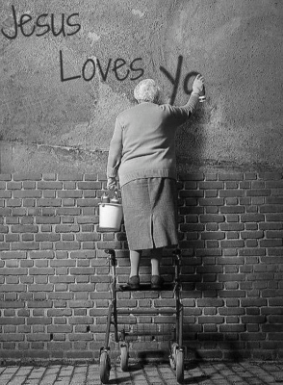
A TALK – toni at Veritas
OH TO BE A GRANNY -
ACT IT!
You've possibly heard those words or maybe thought those words? Expressed in different tones of voice,
possibly with very different emotions behind them. Take a moment to remember your own granny and what
she would have had to say In this short talk I want to unpack a little what it means to be a granny, in
today's society. Few of this group
Let's look at it in this way.
OH TO BE A GRANNY There is the brag-book granny, proud, happy. My little darlings are so cute and so clever. Only 16 months and can...........
OH TO BE A GRANNY There is another show-off granny. “My darlings have done great things. Their father/mother was like that too..
OH TO BE A GRANNY There is the older mother/mom-in-law, waiting, dying for a little one. Children married or not, “Just give me a grandchild to love.”
OH TO BE A GRANNY There is the concerned granny. “Oh what a blessing, in spite of parental neglect. They at least have me to look after them.
OH TO BE A GRANNY There is the supportive granny, “I get satisfaction from being able to help. OH TO BE A GRANNY. There is the disappointed caring granny. They don’t seem to need me.
OH TO BE A GRANNY. Teenage mother. I’m jolly pleased I can leave this child with my mom, so I can get on with my own life, go back to school, get a job.
OH TO BE A GRANNY There is the used/exploited granny, “I wish I wasn't. I'm tired of looking after these brats. They take my pension money, they expect me to provide for them.
OH TO BE A GRANNY. There is the hopeful granny. ”I'm hopeful that these young clever ones will be able to put things right in our world.
CONCLUSION
Some observations and facts to consider.
July is for some of us Grandparents month. What about Women's month – but grandmothers? October month for elderly, but grandmothers? There is a special dimension to being a grandmother/parent rather than just elderly, a family dimension, sense of belonging and commitment, responsibility for ..... in spite of....
A grandmother is a unique and special kind of person, not just any old elderly. The relationship matters, although many do look after other children too. Not all grandparents are elderly, they can be as young as 30s. Many grandmothers are widowed having to adapt to that loss. Many grandmothers are single parents.
Not only grandmothers but grandfathers too play different roles in families.
Other relevant facts: Ethnic, cultural or race dimensions are important. In many cases there are more grannies than dads. 18% of older headed are skip generation, using their grants and
pensions. 8% children grow up with grandparents, but many more are in partial care of grandparents who do not necessarily have authority over them
DON'T FORGET. There are many decisions people get to be able to make in their lives. To marry, to have children, to work, to choose where to live, to come and go. One thing we do not get to choose – to be a grandparent. It is something, a decision, an action of our own children that makes us into grandparents. It also in a sense does not necessarily give us power or status. We are done to, rather than doing, even exploited and at times abused.
Still, it is one of the most important human relationships. For some it is a joy, a gift, a blessing, for others a cross and a burden. It is also a two-way relationship between the older and younger.
Should or shouldn't our young generation think twice before they make the momentous life-changing decision to become parents and us their parents into grandparents? Should they, or not?
Do we have rights?

By their fruits you will know them……
They sat down slowly, stiff limbs welcoming the chance to rest at last. After standing in the seemingly endless queues since early morning the two little old ladies had already shared many of their thoughts and memories. They had seen each other before, as they had waited at the Pensions office for their monthly pay-outs and but had never talked before.
"My husband has been dead for 20 years and in any case he didn't look very well after me and the children he forced on me every year when he came home for his annual leave. I know he had a town wife and they probably spent most of his wages there, but at least he did send a little money home every month,
I had to teach the children. Now I still have my grandchildren. Their mother does worry about them but their father doesn't seem to care. I have had to teach them about God, but how can I tell them of God as a caring and forgiving father I wonder. " And Mrs Mtetwa rambled on.
Mrs Mthembu felt sorry for her companion. She had also been widowed for a long time, but she looked back with good and happy memories. Petrus had been a school-teacher, he had chosen to stay at home and was not tempted by the stories of riches and the good life in the city.
She also had not had an easy life and had certainly learned the quality of compassion. She had become almost a universal grandmother to the other women, even the old, the middle-aged and the young ones who were left behind in the village. She probably could boast about the great things her children had achieved. One son was a doctor and her daughter had traveled overseas on a scholarship for years before she had come back to South Africa with her two children. Gogo's greatest sadness was her young teenage granddaughter Constance,, who used to be such a good girl, committed to her church, active in the youth group and the choir until she had fallen for that handsome salesman. Gogo had dedicated her children and grandchildren to Mary, the Mother of the Holy Family and knew this devotion would
"WHO DO YOU SAY I AM"
A reflection based on the gospel for 24TH SUNDAY OF YEAR B, Mk 8:27-35 from MARFAM booklet EVERY CHILD A NEW SMILE of the 2000 Jubilee of Families. Also available in Afrikaans, Zulu and Sotho. See accompanying image.
serve her as well as the family. So when Constance had come home looking thin and ill her grandmother had hugged the girl and taken her inside, reassuring her that this home was her home.

Not far from the Pensions office in her neat little white- washed cottage Mrs Jacobs switched on her computer. Her pension had been paid into her bank account and she enjoyed managing her finances on-the-line, as she called it. She was very pleased that her youngest grandson Paul had taken the time and trouble to teach his old granny how to use a computer. Now she could email him her latest bits of advice and welcome his mostly patient comments with a smile and a twinkle in her eye.

From the PONTIFICAL COUNCIL DOCUMENT on the
Jubilee of Families. Reflection 11
Utilitarianism is a civilisation of production and use, of "things" and not of "persons". Woman can become an object for man, children a hindrance to parents, the family an institution obstructing the freedom of its members. This can be seen in certain sexual education programmes, in pro-abortion tendencies and so-called "safe" sex" A love which is reduced only to the satisfaction of desire or to a man's and a woman's mutual "use" of each other, makes persons slaves to their weaknesses.
REFLECTION, SHARING, DISCUSSION AND PRAYER
The Jubilee of the Elderly was one of the themes for the Jubilee of Families. The elderly may well become the weakest and considered as having no real value.
Jesus asks, "Who do you say I am?" and then goes on to challenge the apostles to witness to their belief, warning them of the cross that is inevitably part of this witness. All family members, young and old, have the task of witnessing to their beliefs by their own behaviour, their example and the responsible way in which they perform their tasks and duties.

Reflect and share on the following questions:
- In what ways am I willing to witness to my Christian beliefs by taking up the cross in my family?
- HIV/AIDS is a reality in families? Do we talk about it, educate ourselves and our children? Would we be open to accepting a family member who became infected?
- Are we willing to be family for those who have no family?
- Am I caring and supportive towards our elderly?
- As an older person in the family am I considerate or demanding?

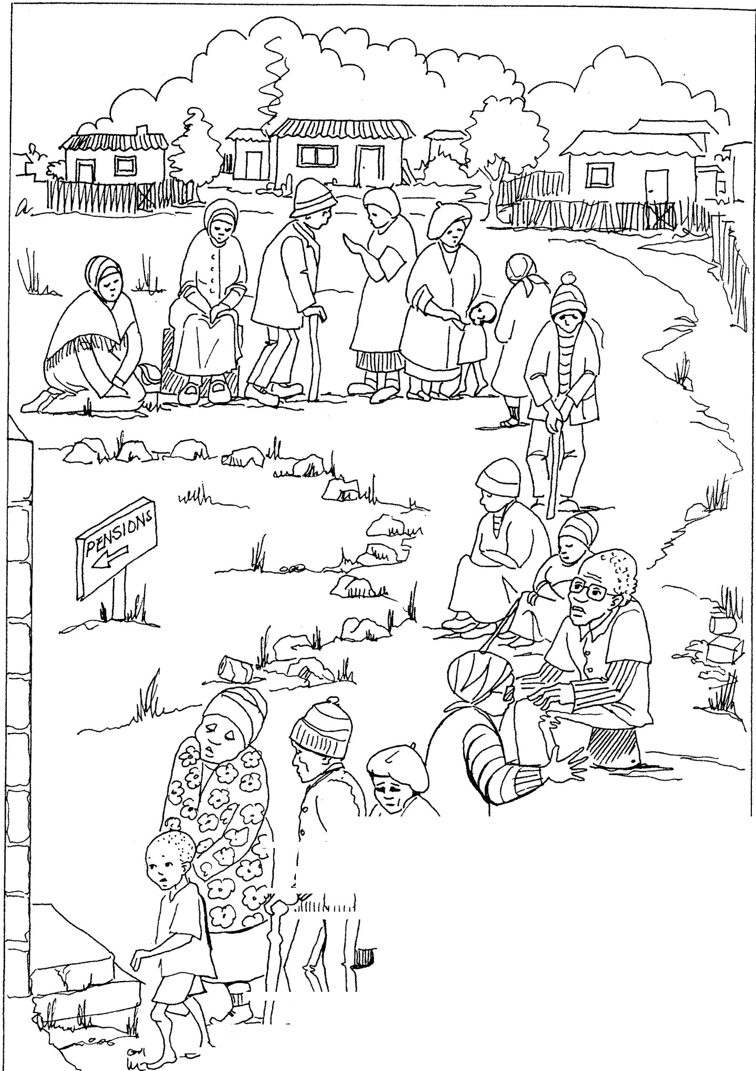
/""
/"t
WV1er1 eac.11 person ries to.LLve good lives tnevnse/Ves.,
•
b
. -- .
u.--Yi)./ ..,_,,,. :-
-
\
Iwitnesses ir1 tl1eir owv1
/
J ,..,......·fawtil and cares for
ot ers) espec,a llLI the elaer! y) the
sicR,and tvlose ivf r1eed, the::j snow
1
.. _.!what tvieltf believe by the UJa tl1e!j
live.Ti1at what beivrg a witness
-,
,,
-= av1d follower of Je8"1S veally means.
·

RELATING
Faith and Life Reflection and Sharing Activity on Parenting
“Father, I pray that they may be one as you and I are one.” John 17:22
(from Parenting a Labour of Love by MARFAM)
A LOOK AT LIFE
The old folks at St Barnabas Retirement Home gathered for their early supper as usual on Sundays. And as this was the day when most family visitors came they always had much to say.
After these visits they would reminisce about the good old days, brag about their children and grandchildren, complain about the state of the world and of family life but deep inside they were confused and concerned too, feeling at a loss, out of touch with how modern families manage their lives. They might be sheltered from the serious problems that were being experienced but they knew all the same.
“I think modern parents don't know how to discipline their children.”
“Children nowadays are spoilt brats demanding and getting far too much money.” “And freedom.” “Parents don't have time to listen and kids don't listen either.” “Neither do they want to listen to us.” “How they find time for relationships with TV and so much else taking up their time I don't know.” “Don't you think working mothers neglect their children?”
“And what about single parents? How can you be mother and father to a child?” “There isn't the love and patience we had.” “Do they know what love is, with all this “safe sex” talk everywhere. Why can't they be taught to save sex for the right person and the right time?”
Through these general criticisms nearly everyone expressed their concern for their own loved ones, their own children, grandchildren or even great-grandchildren, because undoubtedly there is a particular family bond. Mrs Michaelis had been a teacher in her day and now in her 99th year was blessed with wisdom and deep insight. “You know, literally and figuratively, I think that relating is really, and I mean really, getting to the heart of things. And good relationships are the glue that keeps a family together.”
Touched by these pearls of wisdom they could not but agree. It certainly is.
SCRIPTURE references. (select)
“Love one another as I have loved you.” John. 15: 12
“I pray that they will be one as the Father and I are one.” John 17:11 “Remember your father in his old age, even if his mind should fail” Ecl 3:12-14. “Do not drive your children to resentment. Eph 6:4
CHURCH TEACHING from the Catechism of the Catholic Church. (select)
“Honour your father and your mother, that your days may be long in the land which the Lord your God gives you.” The 4th commandment opens the second table of the Decalogue. It shows us the order of charity in that God has willed that, after him, we should honour our parents to whom we owe life and who have handed on to us the knowledge of God. We are obliged to honour and respect all those whom God, for our good has vested with his authority. 2197 Catechism of the Catholic Church. The commandment is addressed expressly to children and includes the duties of parents and all those who govern and exercise authority over others. 2199.
The relationships within the family bring a closeness, affection and interest that come from the respect that members have for one another. 2206 The fruitfulness of married love cannot be reduced solely to the procreation of children, but must also include their moral education and their spiritual formation. 2221

REFLECTION: Relating to one another as parents and children, across three or sometimes four generations, is a task that demands some skill. Listening well means being conscious of the verbal and non-verbal, what is being said and how, and also what might be left unsaid and why. Communication requires respect by both parent and child, as well as being willing to speak out, be open, honest, trusting and trustworthy.
Conflict in such close relationships is inevitable especially as the distance between parent and child has narrowed in some ways and increased in others. Children may be well-educated and more knowledgeable than their parents in this technological age and parents do begin to feel threatened and inadequate. It is not what you know but who you are that matters, and ultimately who you become. Providing the guidance and education to achieve this is the parent's first task and finally the person's own responsibility as they grow into adulthood.
Get professional help if serious problems exist before matters reach crisis levels.
ACTION AND PRAYER RESPONSE :
Consider what action could be taken in the area of parenting in your own life.
Pray for specific needs and for all parents and children that their relationships will be ever more life-giving to one another.

GRANDPARENTS - Zama Ndlovu
Different kinds of emotions come to mind at the mere mention of the word grandpa or grandma. The value of grandparents is different according to different cultures. In most black families they are heads of their families, either because the parents are working far or have passed on. The relationship between grandparents and grandchildren should be an adorable one. St Anne was Jesus Christ's grandmother and I can only imagine their relationship, the games they played together and the folklore stories they shared. As times evolve grandparents are being sent to retirement villages or so called 'old age homes'. One wonderful story I once heard was that of a relationship between Prince Harry and the Queen Mother, his great-grandmother. He actually taught her a lot of Rap songs and nobody could believe their eyes when they saw that side of the Queen Mother, they were actually friends. That's the relationship we would like to expect from these different generations. When the Queen Mother passed on Prince Harry cried the most and was quoted as saying “My best friend is gone.”
When I interviewed one young man who was practically raised by his grandma he said “my gran was the most truthful adult in my life who actually taught me to be independent but at the same time spoiled me rotten.” Then why do some children ill-treat their grannies? There are different reasons for this:
MENTAL HEALTH: Dementia and Alzheimer's bring many changes to the once bubbly granny and children can't understand these changes, sometimes even if these conditions are explained to them. The behaviour changes are just overwhelming even for adults. It is important that the family looks for more information on these conditions or join support groups of other families with similar conditions.
DEPRESSION: Suddenly this once lovable person becomes irritable and withdrawn. They start crying a lot and hiding from other people, keeping to themselves or sleeping all the time. They refuse to eat or bath and maybe both, sometimes becoming very aggressive. They may become very paranoid and this scares children more.
As most children grow older they outgrow the relationship with grandparents and the once wonderful friendship becomes a love-hate relationship.
The stubbornness that comes with old age is another aggravating factor. ABUSE OF THE AGED
Why on earth should the Aged be abused?. The stories are so many and very traumatic. The most painful part is that this abuse happens both at home and in Retirement villages. The abuse is both physical and sexual. There is a myth that if HIV infected people have sex with grannies they will be miraculously cured.
Another form of abuse is neglect; they are locked in bedrooms and starved, sometimes until they die. Communities have turned a blind eye towards all this abuse. These are people who were once desirable parents.
Recently there has been a growing number of grannies dying of HIV/Aids mainly because they have been looking after their children who are infected by the virus. They love their children and grandchildren so much that they died for them. If that is not Agape love then I don't know what is. Our health services have deteriorated so much that one fails to think what the right thing to do is.
WAY FORWARD
July is our month for grandparents mainly because that is the time that we celebrate Christ's grandparents (Anne and Joachim). During this month we can be reminded of how special our grandparents are. In some parishes and organisations there is a hive of activities for them like: adopt a granny, picnics, taking them to beauty parlours, having lunches and a whole lot more. Unfortunately this is just over one month and what about the remaining eleven months. Just imagine what would happen if each one would adopt a granny for life.
What about a granny down the street who needs pampering once in a while and a bowl of hot soup in winter once a week? I'm sure this would make this world a better place.
What about a granny who has not been to Mass in a long time and the new Priest doesn't even know he/she exist? Let's take a step back and do serious introspection especially about our faith. Let's report the abuse and stop sweeping things under the carpet.
The main thing that grandparents need is something that doesn't cost anything, LOVE. A teaspoon of love a day is enough. Let's always remember, these are people that were loving parents once in their lifetime. Most aged people are widows and widowers who may be still secretly grieving for their partners. Family gatherings mean a lot to them. TIME TO THINK!

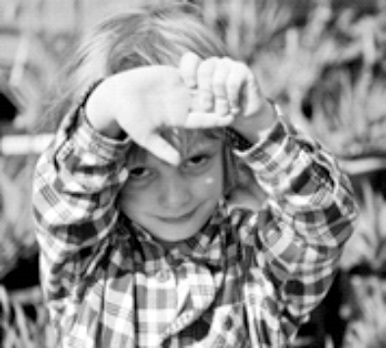
FATHER - GRANDFATHER -
WHICH TO CHOOSE. Peter Stohr
L
ife is a wonderful journey. There are so many
episodes and experiences as one ventures along
one's life. Not all of them of course were
beautiful as I think back on my first memories as a child
Noah was born some four years after Emma. The difference here was that his parents stayed with us, though separate, but on the same property. As his father was away quite a lot due to his work and Noah was a difficult baby, we all had to jump in to help where we could. Especially Hesta became a kind of a second mother to him. Being together also meant that we became fully part of his development and growth. It was again wonderful to see the world anew through his eyes, the beauty of a flower, the fascination of a butterfly, the wonder of the world around him, the trust in his eyes.
One big difference to my being a father, was that I now ran a small business from home. Hence as soon as he could walk he would pop in and of course do what little boys would do – is to play – and of course I would take a break from work. Later on, he would ask me to come and play and I would say, give me an hour to do my work. He would say, that's not too long and would leave with a smile, but five minutes later would be back to come to play!As a 4-year old: Where is God?
As a 5-year old: God is Everywhere!Being a little boy, he loves to play with cars. But as a three-year-old he already knew all the different car models on the road. His desire to better understand the world around him with the hundreds of questions that he asks, including 'where is God?'. He finds Mass boring and most of the time refuses to go to Mass (something us adults must look into having Mass specifically for little ones). Then one day out of the blue he wanted to go with me to a weekday Mass only to find out that he was more interested in finding possible grapes along the fence just outside the church! One ray of light came when we went to a church and his comment was 'this is the bestest priest ever'.
It is a real blessing to be part of Noah's life and to be able to impart on him some of our family values. Now his little sister, Anouk, is already running around and the task of a grandfather becomes even a greater joy. And it keeps us young at heart!
The saying that goes: 'one should first be a grandparent before coming a parent oneself' has many merits, as the responsibility of bringing up children and the pressures placed on young families is much less for a grandparent. For me my children are a beautiful gift from God, with my grandchildren being the cherry on the top!
under communist rule in Eastern Germany. It was a
time where the life of the communities was regulated
against their will, including the closing down of churches and of religious practices. However, what stands out in my mind was the love of my grandparents and what I still cherish today. Unfortunately, as we escaped from East Germany to West Germany my grandparents did not feel up to joining us. Later on, the escape routes were completely sealed off and that was unfortunately the last that I was able to see them.
What an experience to become a father, to see this little miracle baby being part of oneself! But also new responsibilities. New approach to family life, where the accent was not only on husband and wife, but very much focused onto the baby and it's needs. New financial realities, where Hesta, my wife, was the main income earner at the time and we decided that she would stop working so that the child could grow up in a family atmosphere of love. As miracle number two and three appeared very soon afterwards, it took nearly 10years before she could continue with her career, albeit only on a half-day basis.
The one pertinent question I asked myself at the birth of the first child. How will I relate to my child as a father? Should I be the traditional father figure or be more of a friend? It took some dying to oneself to choose the latter, but how rewarding! (much, much later I found out that my German nature did come through!). Coming home from work was generally directed to be with the children till bedtime, whether play, storytelling or just instilling some family culture. (we fortunately could not afford TV at that time).
Life was busy, building house, studying, working, being part of each other's life and before we knew it, the children finished school, then university and out of the house! This left an emptiness, but as parents we were very grateful that each of the children became such beautiful and spiritually deep persons and that they could face the outside world with confidence.
Emma became my first grandchild, yet, at 1500km away, relationship building was restricted to the too infrequent visits. Now that she is older, more frequent communication through Skype and WhatsApp enables one to get know each other better and to play some part in each other's life. However, being a grandfather 'at a distance' is far from being the ideal and much is missed out on both sides.
Family Matters 11
as a 4year old: where is God?
as a 5year old: God is everywhere!

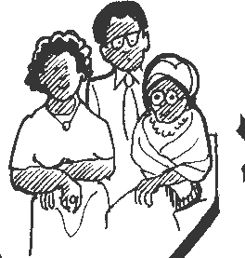
Family Matters 16 2015
THE FEARS AND GIFTS OF THE ELDERLY
I
joined the “Knit and Giggle” group of elderly residents at a retirement village one afternoon to conduct a little
survey. They were happy to chat, but I did find them a little cagey. Do they have many real fears or not, or don’t
think much about them? The women were in the main not afraid of spiders or mice, or of the dark or being alone -
- which many of them are - or of death per se. “If you have faith in God, you need not be afraid.” Losing one’s mind
as in Alzheimer’s disease was discussed at some length. “If you don’t know, then does it matter?” “But in the beginning
you know that you don’t know!”
The group agreed that there are possibly genuine concerns about some of these issues. In different settings there would be all kinds of responses to such a survey as that given below. After some more research we may publish the survey questions and some findings on our website www.marfam.org.za and hopefully some helpful responses will emerge too to help those who have serious fears and phobias and may be reticent and need reassurance about seeking counselling.
Needs and fears of the elderly are very dependent on environmental conditions, whether they live alone, with family, in an upmarket retirement village, as is becoming more and more common among those who can afford it, or in less affluent situations in old age homes. The poor are most vulnerable as they are most dependent on their children, grandchildren and other family members. Other community members or sodalities do tremendous work in visiting and helping housebound grannies and the few grandfathers left alone during the day.
BEATTITUDES FOR GRANDPARENTS
Blessed are the poor in spirit …. as they will not see their grandparents as a mealticket to the future.
Blessed are the gentle ….. as they will recognise and be patient with the weaknesses of old age.
Blessed are they who mourn, and who comfort the bereaved and lonely in their loss.
Blessed are they who hunger and thirst for justice, …. that the old and weak will not be cast aside but be treated with dignity and respect.
Blessed are they who are merciful and who forgive the old for the faults and failings of yesteryear.
Blessed are the pure in heart, who see the old and young as they really are.
Blessed are the peace-makers and the agents for reconciliation between generations.
Blessed are they who accept with grace the wisdom of old age. Blessed are they who can look back on a life of integrity and know they are loved.
Blessed are they who do not judge their young, so that they will not be judged.
Blessed are those who are persecuted because they do what is right, standing up with courage to defend what they have learned through the years.
Blessed are the old and the young, children, parents and grandparents who acknowledge with gratitude the great gift of life they have been given to share.
……… for the Kingdom of God is theirs.
Elderly people with and without dementia or loss of mental capacity and their relatives usually have a lot of fears caused not only by getting bad diseases, criminal violence or financial crisis The most common fears arise from themselves and their home environment. About 50 percent of elderly suffer from a fear of falling. The fear of cooking (can cause fire), the fear of using water (can cause flooding) or forgetting medication (mostly the fear not of the patient itself but his/her relatives) have to be considered too. These fears in general lead to a loss of
self-confidence to move about and engage in activities and social interaction freely. This in itself reduces their activity levels which has health hazards in itself. One could call it a vicious circle, fear to socialise - no friends - more fear to interact - greater loneliness.
A LITTLE SURVEY
ASKING YOU AS AN OLDER PERSON:
WHAT ARE YOUR GREATEST FEARS OR WORRIES?

Mark below what you are afraid of : Then number the 3 greatest fears.
- SPIDERS, MICE, SNAKES, CATS, COCKROACHES, OTHER BUGS
- FALLING
- GETTING SICK, CANCER, ALZHEIMERS, PARKINSONS,
- HAVING AN OPERATION
- BEING ALONE
- THE DARK
- DYING
- DYING ALONE
- LEAVING MY PARTNER OR FAMILY BEHIND
- DRIVING A CAR
- BEING ATTACKED
- ΗAVING AN ACCIDENT AND INJURY
- LOSING MY MEMORY
- ABUSE
- RUNNING OUT OF MONEY
- DEATH OR INJURY OF A CHILD
- DEATH OR INJURY OF A GRANDCHILD
- ANOTHER PERSON IN MY LIFE
- BEING BULLIED
- OTHER......................

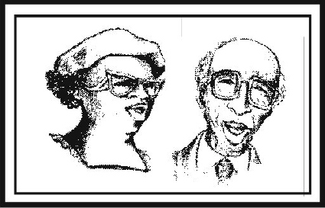
2015 Family Matters 15
THE GOOD OLD DAYS. snippets and poems
The young activist outside the supermarket suggested to the older
WHAT HAVE I DONE WITH MY MIND?
"What have I done with my mind? "
the old lady wondered clutching at threads that wove and unwove patterns in and out of the mist and sunlight of the mind.
women that they could save money by bringing their own shopping bags. Plastic bags cost and they are not good for the environment.
One older woman apologised and explained. “We didn’t have this green thing back then in our time.”
“Yes”, said the activist. “Your generation didn’t care to save the environment for future generations.”
The women discussed the matter in their “Knit and Giggle” group. Back then we returned our milk bottles and beer bottles. The shop sent them back to be washed and sterilized and refilled so we could use the same bottles over an over. So they really were recycled. We even refilled our writing pens with ink instead of buying a new throw-away one.
Back then we had one TV or radio in the house not a TV in every room, And the TV had a small screen the size of a handkerchief, not a screen the size of Eastgate mall.
We blended and stirred by hand because we didn’t have electric machines to do everything for us.
We washed the baby’s nappies and dried clothes on the line not in an energy gobbling machine burning up 2200 watts.
We used wind and solar power all right.
We didn’t fire up an engine and burn petrol just to cut the lawn. We used a push mover that ran on human power. We exercises by working so we didn’t need to go to a health club to run on treadmills that operate on electricity.
Back then we drank water from a fountain or a tap when we were thirsty instead of demanded a plastic one to throw away. We accepted that food was seasonal and didn’t expect Woollies to have out of season products flown in from far away at great cost. We grew and cooked food that didn’t come out of a packet or plastic wrapping. We could even wash our own vegetables and chop our own salad.
Back then kids rode their bikes to school or walked instead of turning their moms into a 24hour taxi service. We had one electrical socket in a room not an entire bank to power a dozen appliances. We didn’t need a computerised gadget to receive a signal beamed from satellites 2000 ks in space in order to order a pizza.
Isn’t it sad how the current generation laments how wasteful we oldies were just because we didn’t the green thing back then. ANONYMOUS
"I think, therefore I am.”
But they say my thinking is off track, meandering off the beaten track perhaps
but still laced with pearls of wisdom and insight.
"I am what I am."
Old in years, in body and in mind
but what matter, age is a blessing as well as a cross. Woman yet, yes as much as at 17, 37 or 67,
woman in appearance, woman in relationship to man, woman and child.
Strong, yet weak Powerful yet powerless,
In control, yet out of control. "I am."
Is this existence, living, being? “I love."
QUESTIONS AND ANSWERS
"Who's speaking?" the little voice asked.
"Hold on granny, I'm going to fetch my pig. Please say hello to him."
"But he didn't say hello to me." "He's not a real pig, silly!" "Why isn't he real?" "Because……. "
GROWING OLD
Why does my foot move so slowly? Why is my hand one big scar?
Why do my eyes seem to run all the time And why can I see just so far?
What better answer to the questions of life? Because…….
Why don't you want to eat your food? Because…. Why can't I play outside? Because……..
Why doesn't he love me any more? Because…..
Why do we ask so many questions about the negative things in life?
Why not , "Why do I feel so happy? Why does he wear that silly smile?
Is it because all pigs are real if you think they are, Even if it is virtual reality.
After all you can't see God, or Father Christmas when he brings your presents in the middle of the night.
Is it dear Lord that I'm just slowing down As I get closer to you
And I carry the weight of my life on my heart, And I'm ready to be, not to do?
Help me to know that "just being" is good, For me and the others I meet.
I can show them and teach them the lessons of life While they help keep me on my feet.

